1.

ps3-1-a-1

ps3-1-a-2

Hint: every time to use the disparity_ssd() function, I need to Initialize the maximum disparity value and window size corresponding to the picture.

2.

a.

ps3-2-a-1

ps3-2-a-2

b.

First of all, the selection of window size will affect the impact of picture matching, not necessarily the most appropriate window size. Second, I think that because of the complexity of the picture itself, the computer does not necessarily match the two pictures to the corresponding points. At the same time, there will be deviations when calculating the distance.

3.

a.

pair1-L-noise

许多照片放在一起

ps3-3-a-1

ps3-3-a-2

I only added gaussian noise to pair1-L.

We can see that the image has become very blurred, but can still see the rough outline with many jumble lines.. Because noise is added, noise will affect it in stereo matching, because in a window, stereo matching is likely to mismatch because of the noise.

b.

pair1-L-contrast10%

ps3-3-b-1

ps3-3-b-2

Only increased the contrast of the pair1-L.

After increasing the contrast, the results are also blurred, but we can still see the general outline. The main reason is that the value of pixel color changes after increasing the contrast, which leads to the wrong point matching in stereo matching, so the wrong depth value is calculated.

4.

a.

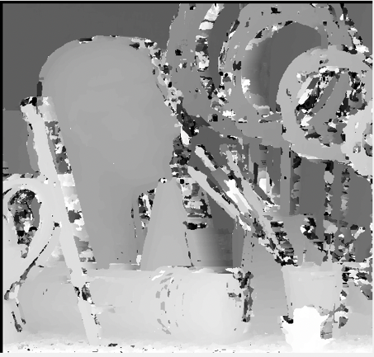

ps3-4-a-1

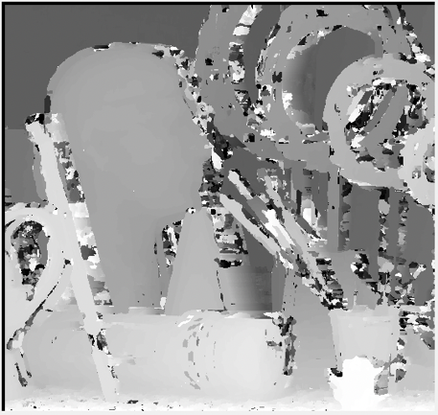

ps3-4-a-2

Compared with the method of SDD, I found that for a whole, such as this portrait, the distance of the whole portrait in the parallax map is the same, while the SDD is still uneven. And the rate of bad pixels is lower.

b.

许多照片放在一起

ps3-4-b-1

ps3-4-b-2

Only add noise on pair1-L.

I found that the image can only roughly see the outline of the object, but it is completely chaotic inside the object. The main reason is that the algorithm can not accurately matching the corresponding points due to the influence of noise, which leads to the wrong distance.

ps3-4-b-3

ps3-4-b-4

The effect is better than add the noise. I can clearly see that the larger object is a complete whole, indicating that increasing the contrast does not have much impact on the ncorr algorithm. Of course, there are still more bad pixels.

5.

ps3-5-a-1

ps3-5-a-2

The depth information can be obtained by calculating the pixel difference between the feature positions of one image and other images. A parallax map is very similar to a depth map because the pixels with large parallax are close to the camera, while the pixels with small parallax are far away from the camera.

In Matlab, I first select a small area in the right image and search for the nearest pixel region in the left image. Similarly, when searching for the image on the right, I start at the same coordinates as the template of the image on the left, searching to the left and right to the maximum distance. The parallax is the horizontal distance between the small area of the right image and the center pixel of the nearest matching area of the left image.